Day in the Life of the Hudson River 10/13/22
Nutten Hook Unique Area
RIVER MILE: 124.5
Salt Front: ~RM 76
Averill Park High School– Elena Oldendorf
52 students & 9 adults
Latitude 42.37°N & Longitude – 73°W

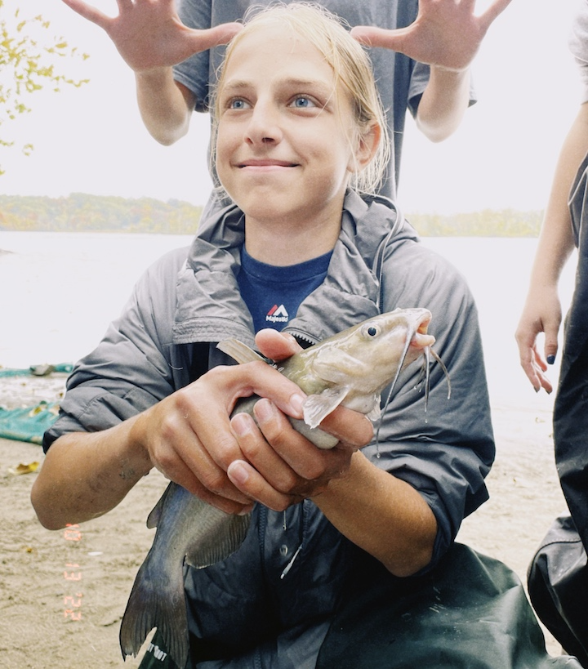 | 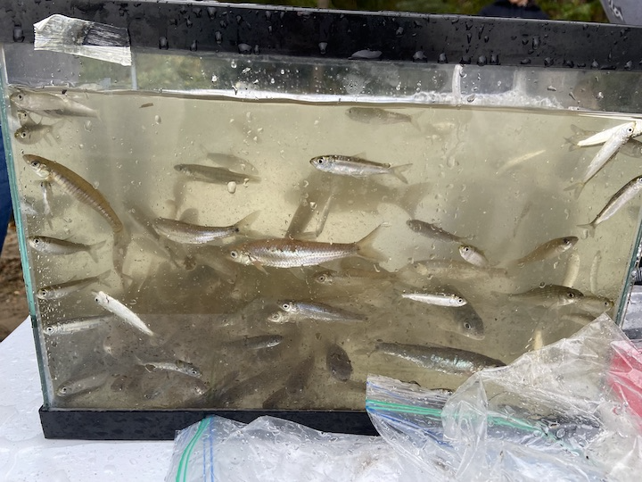 | 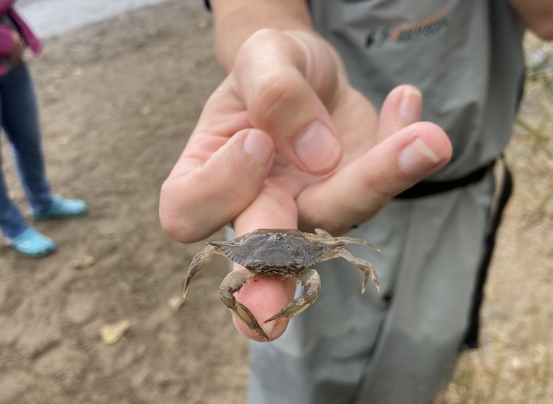

Location: Nutten Hook Park, Green County, NY
Area: NR
Sampling Site: Beach, forested bluff, large marsh behind the bluff, DEC public access, used for picnics, water access after walking down to the beach area
Surrounding Land Uses: Forested; Beach
Shoreline: Beach that is 40% sandy, 40% muddy and 20% rocky
River Bottom: Muddy and sandy
Water: NR
Plants in the Water: Water Chestnuts
*NR = Not read/recorded
ITEM |  | Time |  | Reading |  |  |  | Comments
Physical
Air Temperature- |  | 11:00 AM |  | 17°C |  |  | 62°F
Wind Speed: |  | 11:07 AM |  | Anemometer  0-1 mph |  |  | Beaufort  1 | Direction  S
Weather today |  | 11:09 AM |  | >75% cloud cover |  |  | Drizzle
Weather the past 3 days: |  | Dry
Tides- |  | Time |  | Rising, Falling, Unchanged |  |  | Water Height (cm)
 |  | 11:00 AM-11:33 AM |  | Falling |  |  | 19 cm  5 cm
Current- |  | Time |  | Cm/sec |  | Knots | North/South | Ebb/Flood/Still
 |  |  |  | 7.6  13.3 |  | NR | NR | NR
Water Temperature- |  | 11:20 AM  12:20 PM |  | 16.5°C  16.8°C |  |  | 61.7°F  62.2°F
Turbidity- Long Sight Tube (120 cm) |  | 12:05 PM  12:04 PM |  | 42.55 cm  47.25 cm |  |  | Average 44.9 cm
Chemical
Salinity-Meter/probe |  | 11:15 AM |  | 50 ppm
Standardized Salinity – LR Quantabs |  | 10:00 AM |  | 52 ppm
DO – Meter/probe |  | Time  11:20 AM  12:15 PM |  | Temp  16.5°C  16.8°C |  |  | ppm DO  8 ppm  7.9 ppm | % saturation  86.5%  90%
pH –Meter |  | 11:15 AM |  | 7.225
Nitrates- NR
Phosphates- NR
Alkalinity- NR
Biological-
Fish – Kick net |  | Number |  | Name |  |  | Length of longest | Length of smallest
10:40 AM-12:00 PM |  | 1  67  2  3  70  1  58  1  20  4  5  3  2 |  | American Eel  Herring sp.  Bay Anchovy  Golden Shiner  Spottail Shiner  Channel Catfish  Banded Killifish  Mummichog  White Perch  Striped Bass  Sunfish spp.  Pumpkinseed  Hogchoker |  |  | 11.5 cm  41 cm  10.5 cm  13 cm  9 cm | 9.5 cm  10 cm  10.5 cm
Fish Totals |  | TOTAL: 237 |  | Diversity: 13
Macroinvertebrates |  | Number |  | Name |  |  | Length of longest | Length of smallest
 |  | 4 |  | Blue Crab
Macroinvertebrate Totals |  | TOTAL: 4 |  | Diversity:1
Sediment Core – @ 42.37 N 73 W
Length | H2S smell |  | Oxid Top |  | Oil |  | Grain Size | Other Features
NR | NR |  | Yes |  | No |  | Abundant: sand  Common: pebbles  Rare: clay, mud, gravel | Common: Leaves and shells
Boats- NR
 | Time |  | Name |  | Color |  | North/Southbound | Light/Loaded
Commercial
Recreational

